- Develop a program using malloc(), calloc(), realloc(), and free(). Monitor memory allocation behavior and identify memory leaks using Valgrind.

Code: #include <stdio.h>
#include <stdlib.h>

int main() {
int i;

// malloc()
int *arr = (int *)malloc(3 * sizeof(int));

if (arr == NULL) {
printf("Memory allocation failed\n");
return 1;
}

printf("Memory allocated using malloc()\n");
for (i = 0; i < 3; i++) {
arr[i] = (i + 1) * 10;
printf("%d ", arr[i]);
}

// calloc()
int *carr = (int *)calloc(3, sizeof(int));

if (carr == NULL) {
printf("\nCalloc allocation failed\n");
free(arr);
return 1;
}

printf("\n\nMemory allocated using calloc()\n");
for (i = 0; i < 3; i++) {
printf("%d ", carr[i]);
}

// realloc()
arr = (int *)realloc(arr, 5 * sizeof(int));

if (arr == NULL) {
printf("\nReallocation failed\n");
free(carr);
return 1;
}

arr[3] = 40;
arr[4] = 50;

printf("\n\nMemory resized using realloc()\n");
for (i = 0; i < 5; i++) {
printf("%d ", arr[i]);
}

// free()
free(arr);
free(carr);

printf("\n\nMemory freed using free()\n");

return 0;
}

Output: 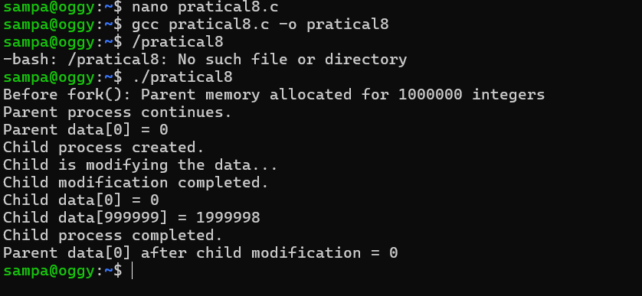

Develop a program that demonstrates Copy-on-Write behavior after a fork(). Analyze memory usage before and after modifying data in the child process
Code: #include <stdio.h>
#include <stdlib.h>
#include <unistd.h>
#include <sys/wait.h>

#define SIZE 1000000

int main() {
int *data = malloc(SIZE * sizeof(int));

if (data == NULL) {
perror("malloc");
return 1;
}

for (int i = 0; i < SIZE; i++) {
data[i] = i;
}

printf("Before fork(): Parent memory allocated for %d integers\n", SIZE);

pid_t pid = fork();

if (pid < 0) {
perror("fork");
free(data);
return 1;
}

if (pid == 0) {
printf("Child process created.\n");
printf("Child is modifying the data...\n");

for (int i = 0; i < SIZE; i++) {
data[i] = data[i] * 2;
}

printf("Child modification completed.\n");
printf("Child data[0] = %d\n", data[0]);
printf("Child data[999999] = %d\n", data[999999]);

free(data);
exit(0);
}
else {
printf("Parent process continues.\n");
printf("Parent data[0] = %d\n", data[0]);

wait(NULL);

printf("Child process completed.\n");
printf("Parent data[0] after child modification = %d\n", data[0]);

free(data);
}

return 0;
}

Output: 